**7 Database Paradigms**

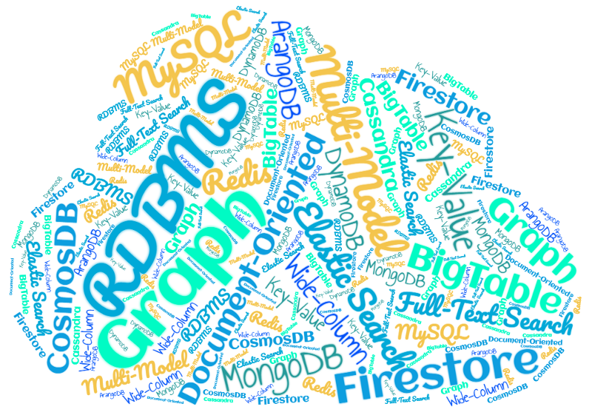

Once a wise man said, “Use the right tool for the right job.”

This also applies to choosing a database when building an application. There are 7 types of databases: Key-Value, Wide-Column, Document-Oriented, Relational (RDBMS), Graph, Full-Text Search, and Multi-Model. Only three of them: RDBMS, Document-Oriented, and Key-Value are widely known.

**1. Key-Value**

The first and simplest database type in the list is Key-Value. It stores data in the form of key-value pairs in RAM. As it stores data in RAM, it is the fastest database type, performance-wise. It is mostly used for caching.

Popular key-value databases are Redis and Memcache. Twitter uses Redis to store cache on the server.

**2. Wide-Column**

The second type is wide-column.